Gospel song!Gospel song!!Gospel Song!!!
Welcome to:
The Christian Faith Gospel Church,Gospel Inspiration,
On Saturday, 11th Sept.2010,at 12.00pm.

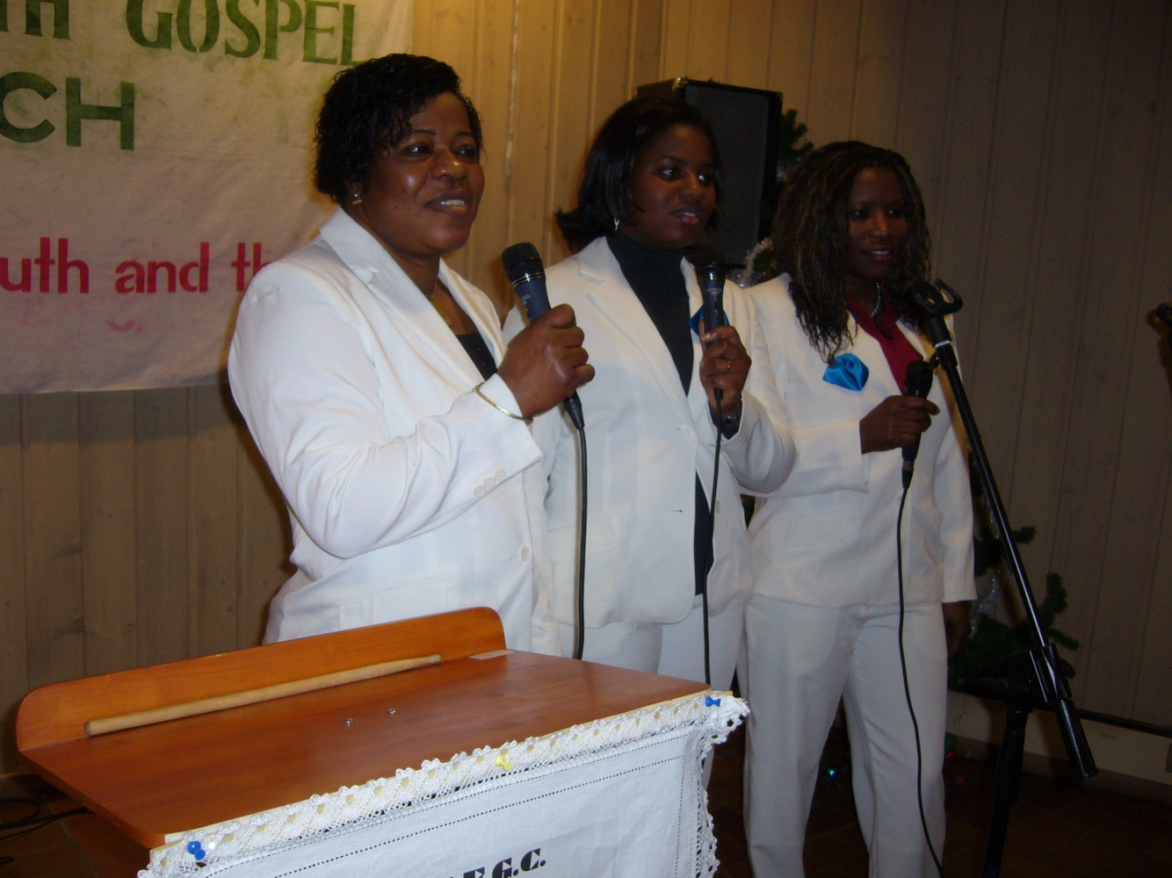
Meet The C.F.G.C, Choir.

Venue:Baptish Church,Torgeir Vraas plass 7,Stromsø,Drammen.

“Let every thing that hath breath praise the Lord.Praise ye the Lord”. Ps 150:6
Come and experience the power of praise and worship for healing in your life.

